A

Progress Report On

Automation Odoo HRMS

Submitted To

**Chitkara University, Punjab**

For

**MCA**

**By**

**Amar Arora**

**Roll No: 2310987016**



**Under the supervision of**

**External Supervisor**

**Ms. Ruchika Sharma**

**Senior Technical Trainee**

**BTES**

# 1. Introduction- Organization

**1.1 Overview of the Company and its Projects and Technologies**

Founded in August 2002, Bebo Technologies is a leading provider of software engineering services with a strong focus on offshore outsourcing. The company has built a reputation for excellence, successfully delivering numerous projects for prestigious clients such as Amazon, Adobe, Ford, Apple, Cisco, IBM, and Oracle.

**1.2 Services and Expertise:**

Bebo Technologies offers a diverse range of services designed to address the unique needs of its clients:

1. **Development Services:** Delivering tailored software development solutions using cutting-edge programming languages and database technologies.
2. **Product Support Services:** Ensuring smooth functionality and maintenance of software after deployment.
3. **QA and Testing Services:** Delivering outsourced quality assurance services to streamline software development processes.
4. **Professional Services:** Offering expert consulting to solve specific business challenges.

**1.3 Projects and Technologies:**  
Bebo Technologies is actively involved in creating AI-driven tools for quality assurance and automation frameworks utilizing computer vision. Their expertise extends to object detection and recognition, reflecting their dedication to incorporating advanced technologies into their solutions.

**1.4 Company Culture and Values:**  
The organization prioritizes a supportive work environment, individualized development plans, and challenging projects to foster career growth.

**1.5 Summary**:

Bebo Technologies is a trusted partner for companies seeking comprehensive software engineering services. With a team of seasoned professionals, the company is committed to delivering exceptional solutions tailored to clients' needs.

# 2. INTRODUCTION OF PROJECT

# TESTING OF ODOO HR MANAGEMENT SYSTEM

The Odoo HR Management System testing process ensures that the platform operates seamlessly, meeting functional requirements. FunctionL testing is essential to identify and address any issues, ensuring a reliable and user-friendly system. Below is the detailed testing approach:

**2.1 Testing Objectives**

1. Verify that all HRMS features, such as employee management, attendance tracking, and function as intended.
2. Ensure the system meets Functional requirements.
3. Identify and resolve any bugs or vulnerabilities to deliver a high-quality product.

**2.2 Testing Methodology**

1. **Manual Testing:**
   1. Validate core functionalities by performing hands-on test cases.
   2. Focus on user-centric scenarios to ensure usability and intuitiveness.
2. **Automated Testing:**
   1. Use tools like Selenium for regression and functional testing.
   2. Execute repetitive tasks and scenarios to validate system consistency.

**2.3 Testing Stages**

1. **Unit Testing:**
   1. Test individual modules, such as employee registration, attendance tracking, and payroll processing.
   2. Ensure accurate data flow between components.
2. **Integration Testing:**
   1. Validate the interaction between modules, e.g., linking attendance data to payroll processing.
   2. Ensure seamless integration with external systems like payment gateways.
3. **System Testing:**
   1. Test the HRMS as a whole to ensure it meets functional requirements.

**2.4 DATA FLOW DIAGRAM:**

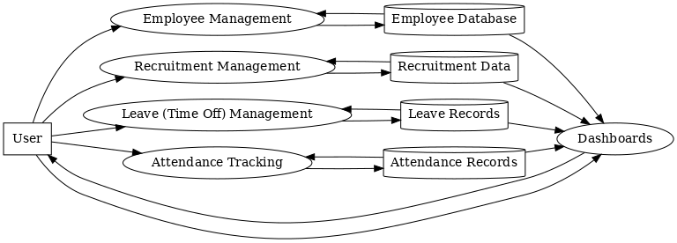

**2.5 Outcome:**

The testing process successfully ensured that the Odoo HR Management System:

1. Operates without critical bugs.
2. Offers a seamless, intuitive user experience.
3. Meets security and performance standards.
4. Provides accurate and efficient HR functionalities.

This robust testing approach guarantees that the system can be deployed confidently, delivering value to HR departments and enhancing overall operational efficiency.

**3.Introduction to Tasks/Subtasks Assigned**

**3.1Module 1 - Manual Testing:**

1.Part 1: Testing Concepts

2.Part 2: Test Project Execution

3.Part 3: Agile-JIRA (Procedure-Oriented)

4.JIRA - Agile Test Management Tool (Tracking Tool)

**3.1.1 Testing Concepts**  
Manual testing is the process of validating that a software application behaves as expected without relying on automation tools. Testers perform test cases manually to ensure the application adheres to its specified requirements. Below are the fundamental concepts of manual testing:

**3.1.2 Understanding Requirements**

1. **Business Requirements**: Comprehend the objectives the system is meant to fulfil.
2. **Functional Requirements**: Identify the specific functionalities the system must execute.

**3.1.3 Test Planning**

1. **Test Plan**: Document detailing the scope, goals, resources, and schedule for testing.
2. **Entry and Exit Criteria**: Define the conditions to start and conclude testing.

**3.1.4 Test Design**

1. **Test Scenarios**: Broad-level situations or features to test.
2. **TestCases:** Step-by-step procedure to validate specific functionality.
3. **Test Data**: Prepared data used for executing test cases, including edge and boundary cases.

**3.1.5 Test Execution**

1. **Executing Test Cases**: Manually performing actions to observe the application's behavior.
2. **Defect Logging**: Reporting discrepancies, bugs, or issues in defect management tools like Jira or Bugzilla.

**3.1.6 Testing Techniques**

1. **Black Box Testing**: Testing without knowing the internal code.
2. **White Box Testing**: Testing with knowledge of internal code.
3. **Gray Box Testing**: A combination of black-box and white-box testing methods.

**3.1.7 Defect Life Cycle**

1. **New**: Defect is identified and logged.
2. **Assigned**: Defect is assigned to a developer.
3. **Open**: Developer begins resolving the defect.
4. **Fixed**: The issue is resolved by the developer.
5. **Re-Test**: Tester verifies the fix.
6. **Closed**: Defect is resolved, validated, and accepted.
7. **Reopened**: Defect persists after the fix and requires further attention.

**3.1.8 Test Reporting**

1. **Test Summary Report**: Overview of testing efforts, results, and metrics.
2. **Defect Report**: Comprehensive details about identified defects.

In this module, we covered the foundational concepts of manual testing, including:

1. The definition and purpose of testing.
2. Scenario-based questions to deepen understanding, such as:
3. How can we determine if a product is of high quality*?*
4. Provide an example where manual testing identified a critical bug.
5. Process models.
6. Quality Assurance (QA).
7. Validation and Verification.
8. The relationship between Cost of Quality (COQ).
   1. 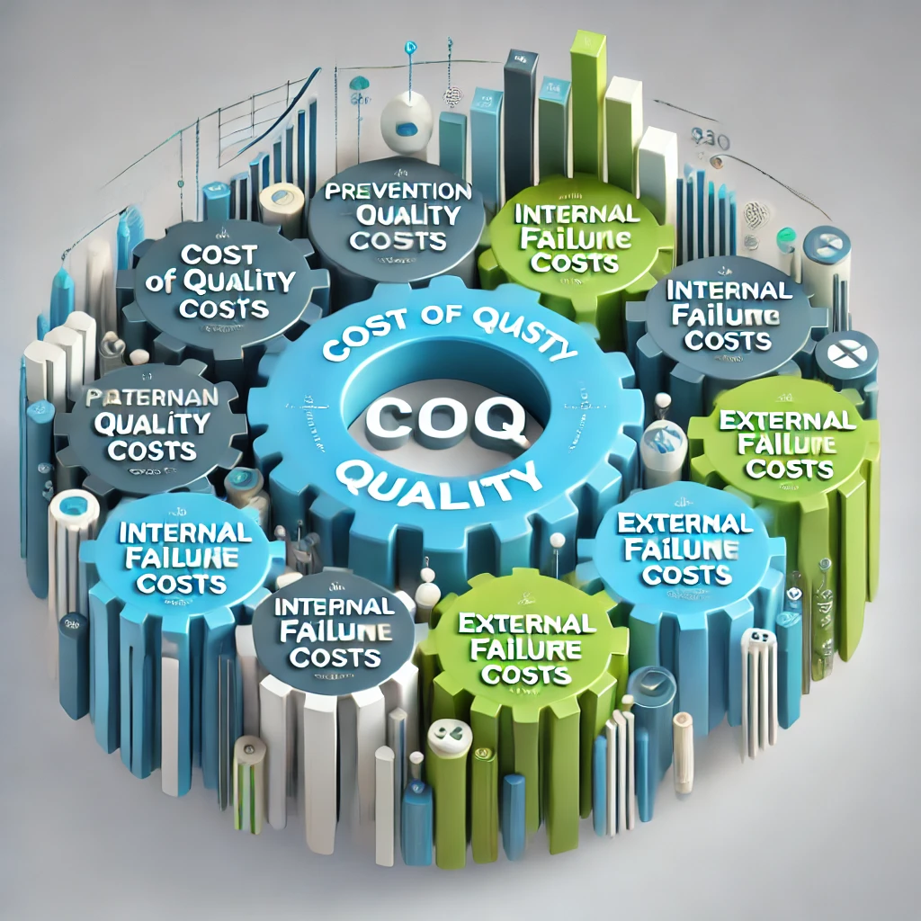
9. Levels of Testing.
10. Testing Principles.
11. Software Testing Terminology (Types of Testing).

**Additional Topics**

1. **J-Meter**.
2. **Agile Methodology**.



**3.1.9 Test Design Techniques**

1. **Equivalence Class Partitioning**.
2. **Boundary Value Analysis**.

**Software Testing Life Cycle (STLC)**

Under this we have Test plan contents.

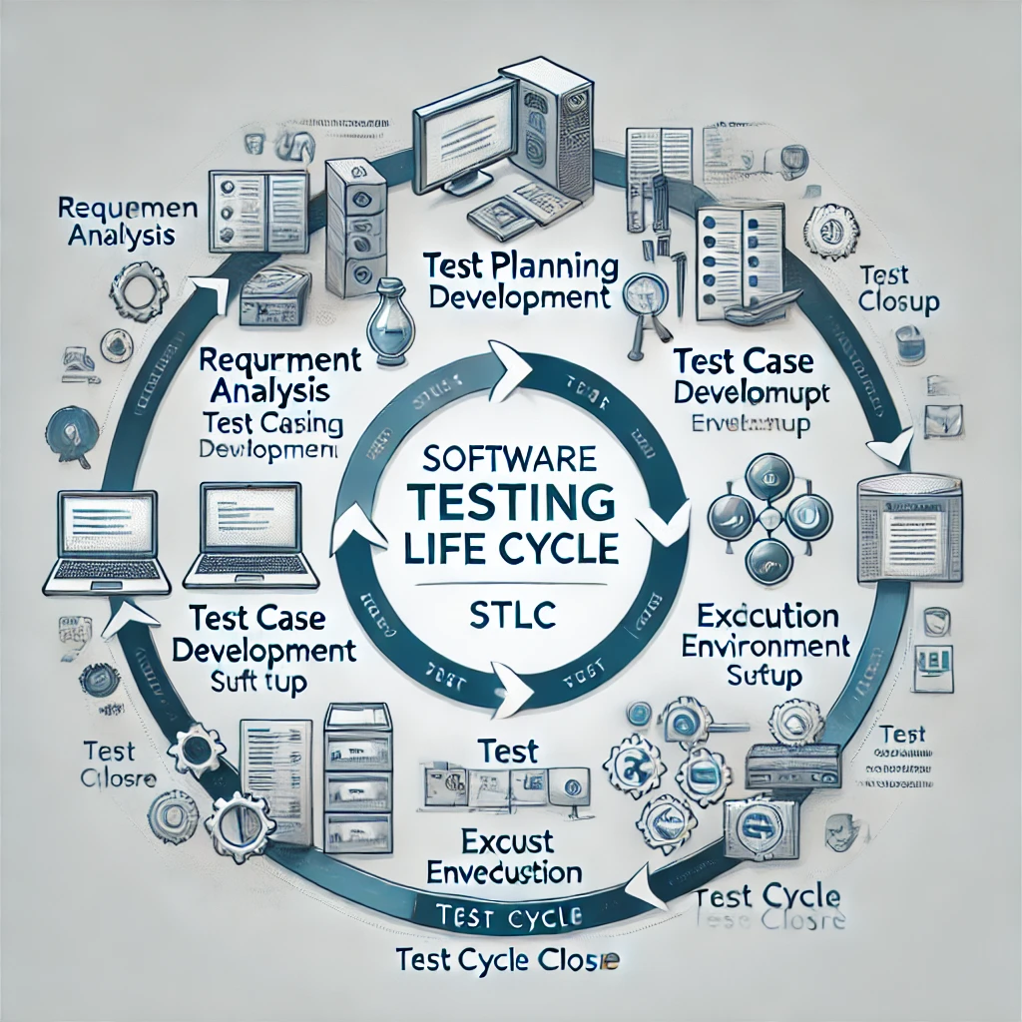

In this section, we explored the contents of a test plan and gained an understanding of:

* Test cases.
* Use cases.
* Test scenarios.

**Bug Reporting**:

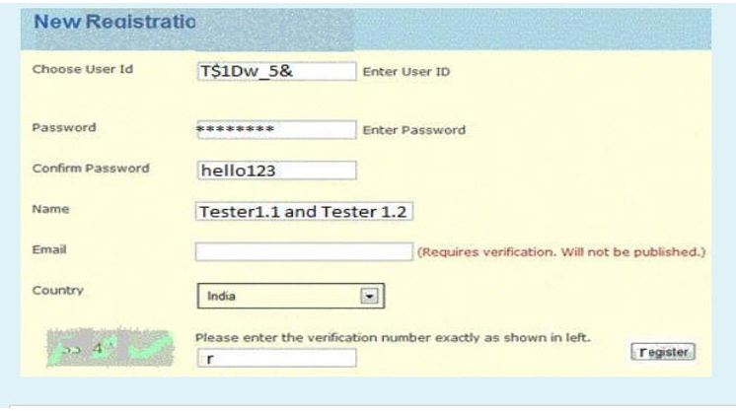

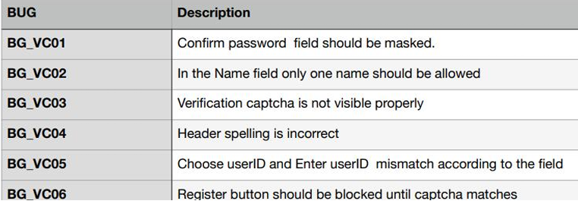

**Module 2**

**Python Language**

This module covered the fundamentals of Python programming, preparing us to work with automation tools and write efficient scripts for testing web applications.

**Module 3**

**Selenium with Python**

In this module, we focused on implementing automation testing

for web applications using Selenium integrated with Python.

This included creating test cases, writing scripts.

1. **Studies on Open-Source HR Platforms:**
   * Research emphasized understanding the usability, functionality, and flexibility of open-source platforms like Odoo HRM. The focus was on evaluating its ability to meet the needs of businesses of all sizes, particularly small and medium enterprises (SMEs).
   * Comparative analysis assessed how Odoo HRM stands out in terms of feature set, user experience, and modularity when compared to other HR solutions like Zoho People or BambooHR.
2. **Testing and Quality Assurance of Web Applications**
3. **Automation vs. Manual Testing:**
   * Our project highlighted the integration of automated tools like Selenium WebDriver alongside manual testing to ensure comprehensive test coverage.
   * The Odoo HRM Recruitment module on localhost was utilized as a testing environment to practice designing and executing both manual and automated test cases.
4. **Functional Testing Approaches:**
   * Focused on validating core functionalities of the Recruitment module, such as job position creation, application management, and recruitment workflow tracking.
   * Test cases ensured that essential HR operations like job publishing, application handling, and dashboard filters functioned as intended.
5. **Application of Testing Tools**
6. **Selenium-Based Testing:**
   * Selenium WebDriver was used to automate test cases in the Odoo HRM Recruitment module. These included login/logout functionality, form validations for job positions, error handling, and publishing/unpublishing job postings.
7. **Bug Tracking and Reporting:**
   * Bug-tracking tools like Jira were integrated into the testing process to record and manage defects identified during validation. This helped in improving the module's overall quality and reliability.
8. **Domain-Specific Use Cases**
9. **HR Process Automation:**
   * The project explored how Odoo HRM automates critical HR processes, such as recruitment workflows, applicant tracking, and job activity notifications, contributing to operational efficiency.
10. **Educational Use of Odoo HRM on Localhost**

* **Learning Environment:**
  + The Odoo HRM Recruitment module served as an effective tool for learning and practicing software testing techniques. It provided a realistic environment to simulate real-world HR scenarios.
* **Case Studies and Projects:**
  + Academic projects utilized Odoo HRM to create and execute test cases, addressing challenges related to system implementation and testing methodologies.

**Key Insights from the Project**

* **Modular Design:** Odoo HRM’s modular structure allows for easy customization and scalability, making it an excellent choice for businesses of all sizes.
* **Structured Testing:** The importance of detailed test case creation was emphasized, particularly for critical functionalities like job management and applicant workflows.
* **Automation Tools:** Selenium WebDriver and JMeter proved effective for automating functional and performance tests, while Jira streamlined the bug-tracking process.
* **Practical Learning:** Odoo HRM on localhost provided a robust test bed for applying theoretical concepts in software testing and gaining hands-on experience in automation.

**Generation of Test Cases:**

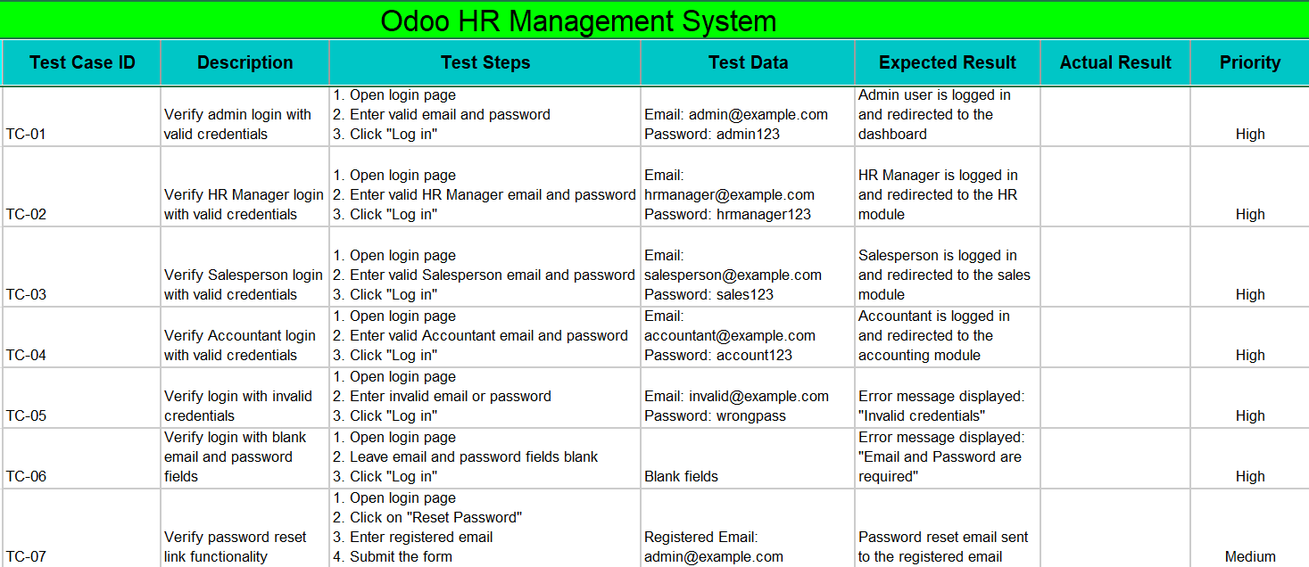

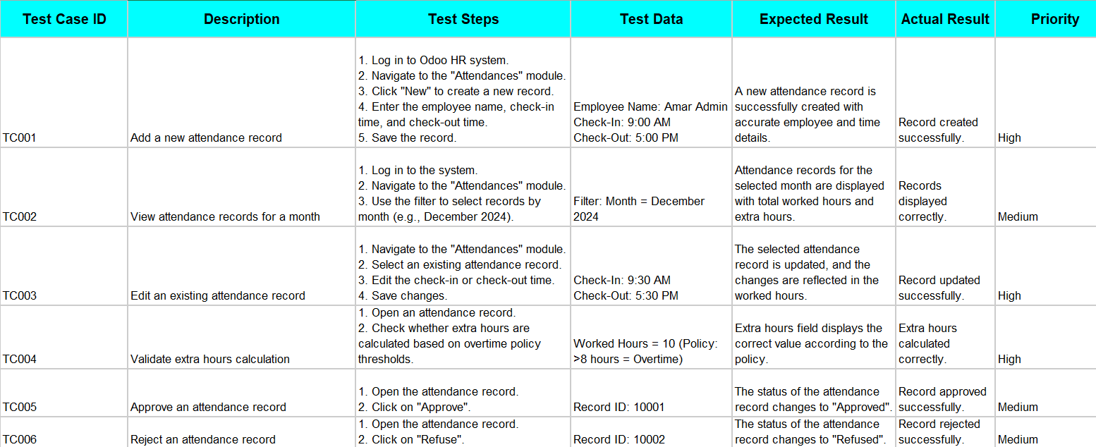

Testing the Odoo HRM site using Selenium with Python requires both hardware and software that can effectively support the testing process. Here's an overview of the hardware and software requirements:

**Hardware Requirements**

* **Processor**: Dual-core processor (Intel i3 or equivalent) is sufficient for basic testing; for complex test cases or parallel execution, a quad-core processor (Intel i5/i7 or equivalent) is recommended.
* **RAM**: Minimum 4 GB; 8 GB or more is recommended to handle browsers, test execution, and additional tools like IDEs or testing frameworks smoothly.
* **Storage**: At least 10 GB of free space to accommodate the operating system, Selenium libraries, browser drivers, and test reports.
* **Display**: Screen resolution of at least 1280x1024 for testing UI layouts and responsiveness.
* **Network**: A stable internet connection to access the Odoo HRM site and download necessary dependencies.

**Software Requirements**

* **Operating System**

Windows, macOS, or Linux (any modern version supported by the browser and Python runtime).

* **Python**

Python 3.7 or newer. It can be downloaded from Python's official website.

* **Web Browser**
* Browser Drivers

Compatible WebDriver for the browser in use:

**ChromeDriver** for Google Chrome.

**GeckoDriver** for Mozilla Firefox.

**EdgeDriver** for Microsoft Edge.

**SafariDriver** for Safari (comes pre-installed with macOS).

* **Selenium**

Install the Selenium library using pip:

pip install selenium

* **IDE/Code Editor**

An Integrated Development Environment (IDE) or text editor for writing and executing test scripts, such as:

* + PyCharm
  + Visual Studio Code
  + Jupyter Notebook
  + Sublime Text
* **Testing Frameworks (Optional)**

Use a test framework to manage test cases and assertions:

**unittest** (built into Python)

**pytest** (installable via pip install pytest)

* **Reporting Tools (Optional)**

For enhanced reporting, integrate tools like Allure Reports or generate HTML reports using Python frameworks.

* **Other Tools**

A version control system like Git for managing test scripts.

* Virtual environments to isolate project dependencies.

**Additional Considerations**

1. System Compatibility: Ensure the OrangeHRM demo site functions on the selected browser and operating system.

2. Parallel Testing: For running multiple test cases simultaneously, tools like Selenium Grid or cloud-based services like BrowserStack or Sauce Labs can be used.

3. Headless Testing: If running tests in a headless mode, ensure sufficient hardware resources to handle browser execution in the background.

By meeting these requirements, you can ensure an efficient and seamless testing experience on the Odoo HRM site.

**DESIGN**:

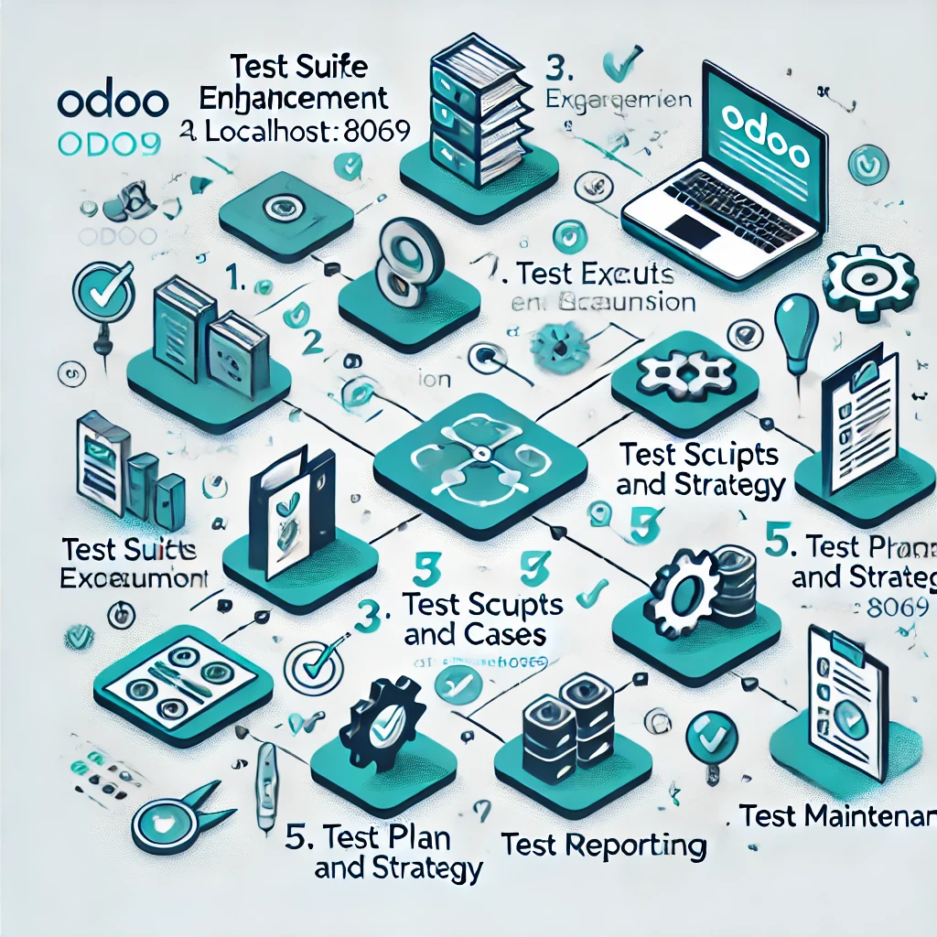

**6.Detailed Description of New Functionalities added or activities underwent**

1. **Identifying Test Scenarios:** Various test scenarios were identified based on the user requirements and business use cases. Each scenario was carefully designed to validate specific functionalities such as login, form validation, and error handling.

Writing Test Cases: Test cases were drafted for every identified scenario. These test cases included the steps for execution, expected outcomes, and criteria to determine pass or fail. Each test case was mapped to the corresponding requirement, ensuring traceability.

1. **Transition to Automation:**

Automation Using Python**:** Python scripts were implemented to automate the testing process. The environment was set up with essential libraries, including Selenium WebDriver, to interact with web elements effectively.

Browser-Based Workflow Automation**:** Selenium was leveraged to automate key workflows like logging into the application, filling out forms, and navigating through the app. Scripts were written to execute these tests automatically and validate the app's behavior.

1. **Selenium Automation:**

Element Interaction**:** The automation scripts utilized Selenium to locate web elements by attributes like ID, name, and XPath. This allowed for efficient interaction with UI elements such as input fields and buttons.

Test Execution: The scripts were executed against various test cases to validate functionalities, such as form submissions, successful login, and proper error messages for invalid inputs.

1. **Validation of Test Results:**

Assertions: After executing the tests, results were validated using assertions to ensure the actual application behavior aligned with the expected behavior.

Result Logging**:** The test results were logged in a structured format, highlighting the success or failure of each test case. These logs were thoroughly reviewed to confirm that the application’s functionality met the required standards.

1. **Collaboration and Team Interaction:**

Actively collaborated with the development team to stay updated on new features and functionalities being added to the application. This interaction helped in crafting focused test cases and automating crucial workflows.

Participated in sprint planning meetings, where feedback was provided on test results, issues were raised, and efforts were made to ensure that the product met the quality standards.

# REFRENCES

1. **Odoo, “Odoo Official Website,”** [Online]. Available: <https://www.odoo.com>
2. **Odoo, “Odoo HRM Documentation,”** [Online]. Available: <https://www.odoo.com/documentation>.
3. **Selenium, “Selenium Documentation,”** [Online]. Available: <https://www.selenium.dev/documentation>.
4. **Python Software Foundation, “Python 3.10 Documentation,”** [Online]. Available: <https://docs.python.org/3/>.
5. **ChatGPT, “OpenAI ChatGPT Documentation,”** [Online]. Available: <https://openai.com/chatgpt>.
6. **PrefixLite, “PrefixLite Performance Testing Guide,”** [Online]. Available: <https://www.prefixlite.com/documentation>